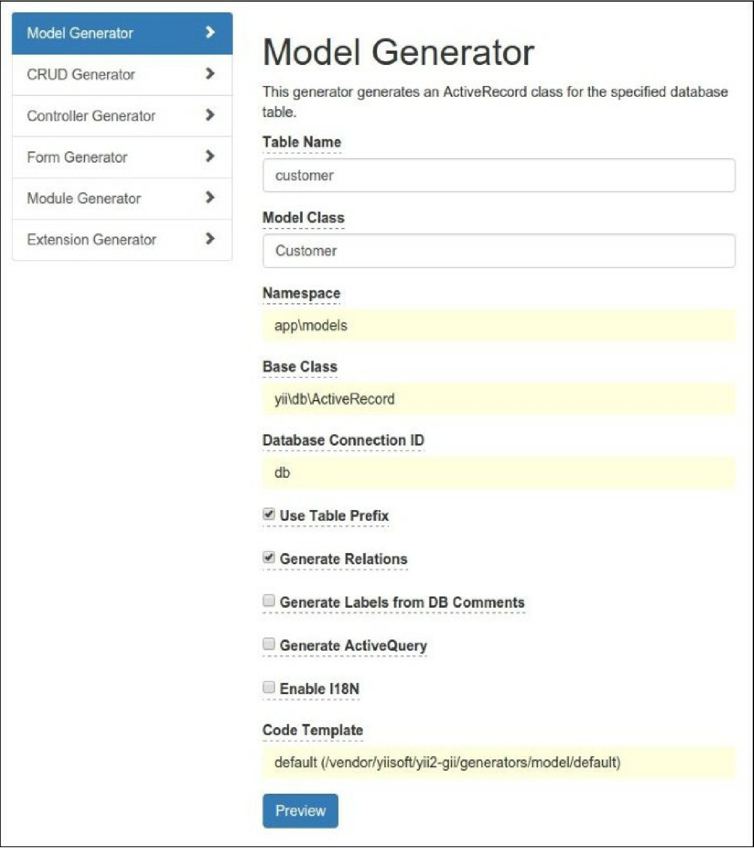

5. Click the Preview button. You must view the featured files list: